**EMPLOYEE ATTENDANCE**

**Overview:**

**“**Employee Attendance”, a simple web application where the user can store employee details and attendance for an organisation. It includes adding new employees,storing and updating details into the system . The user can provide the atendance entry for all employees on particular day. Finally the application generates the total attendance report.

**System Requirements:**

Languages : Python, SQL

Framework : Flask

Database : SQLITE 3

Tools used : Visual Studio Code

Web Technologies : HTML,CSS,JavaScript.

**Screens:**

**Home Page:**

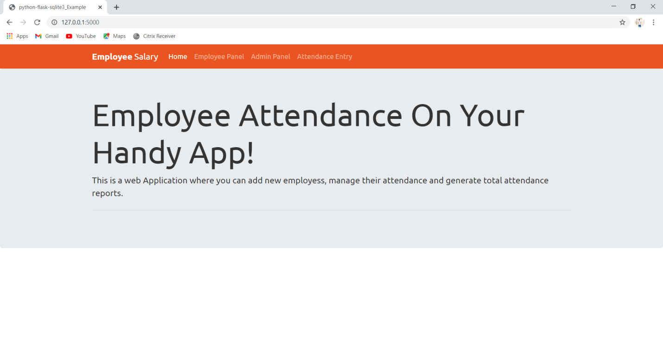**Employee Page:**

The page where user can add new employees with unique Employee ID.

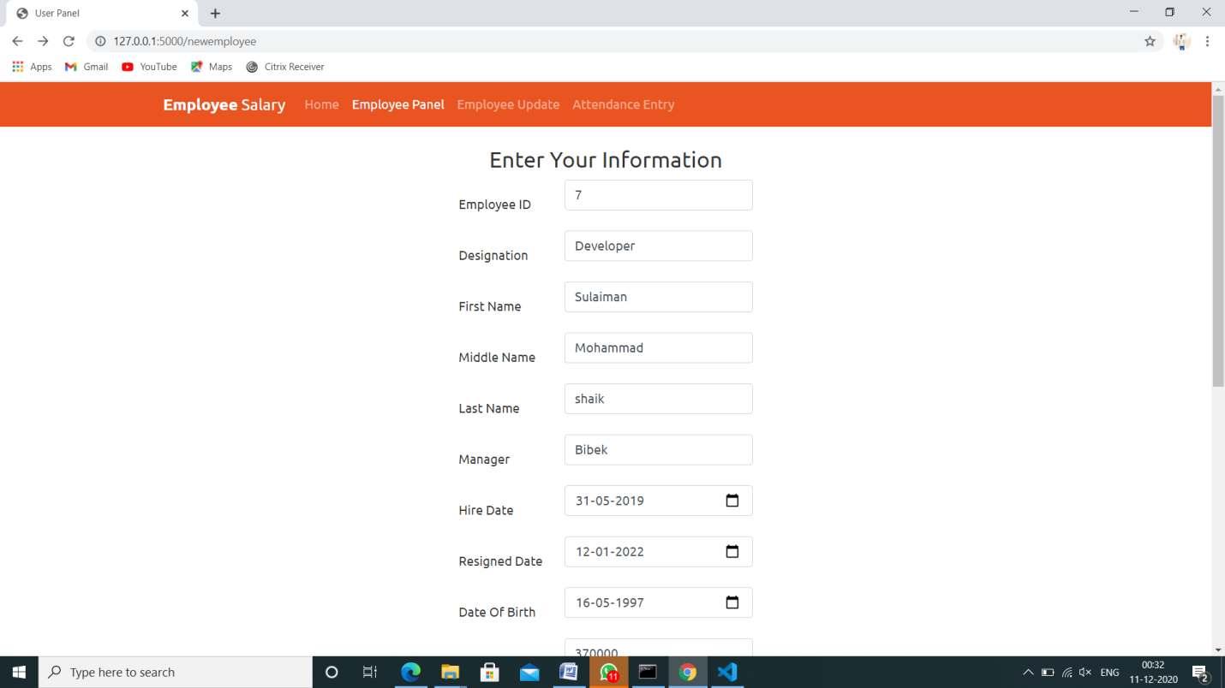

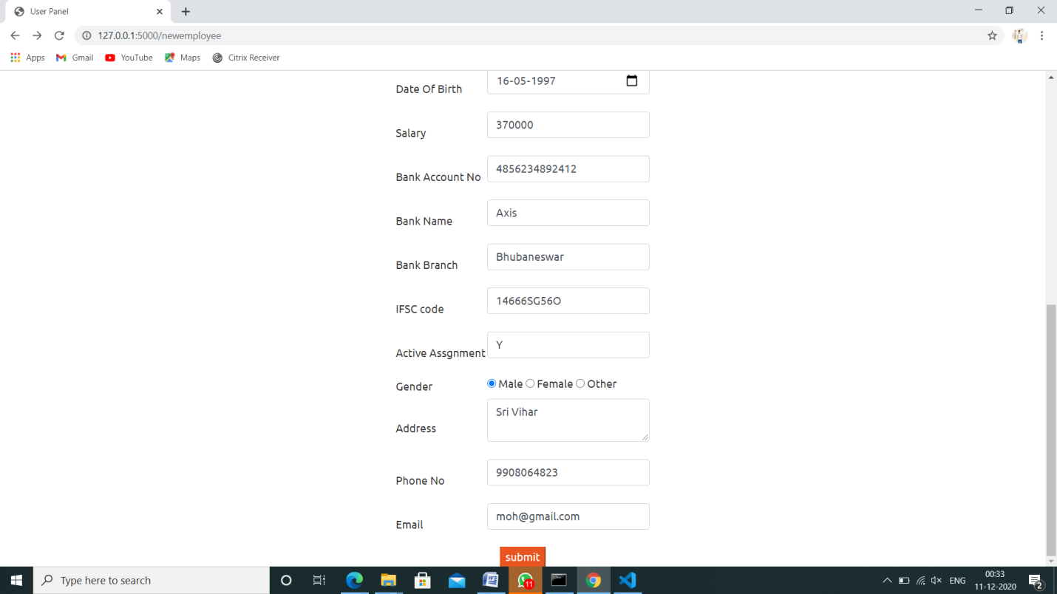

Validations had been added

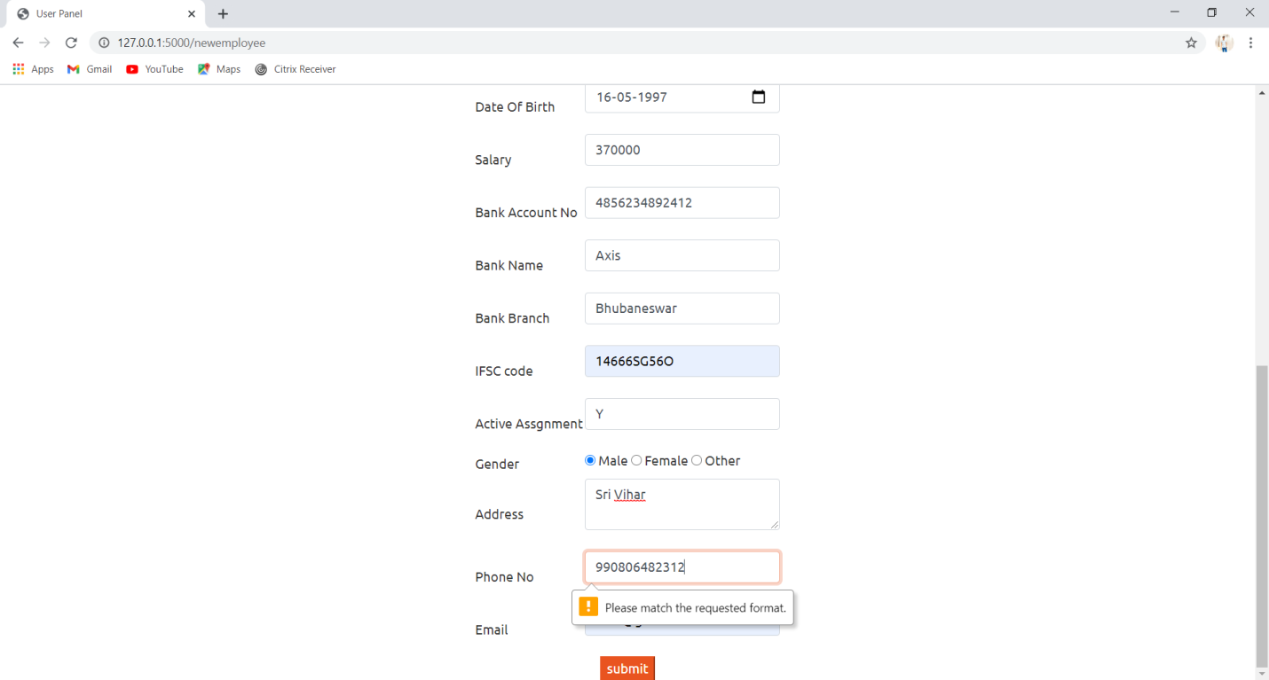

**Employee Update Screen:**

The system allows to select the Employee ID to get the details and can update the details if required.

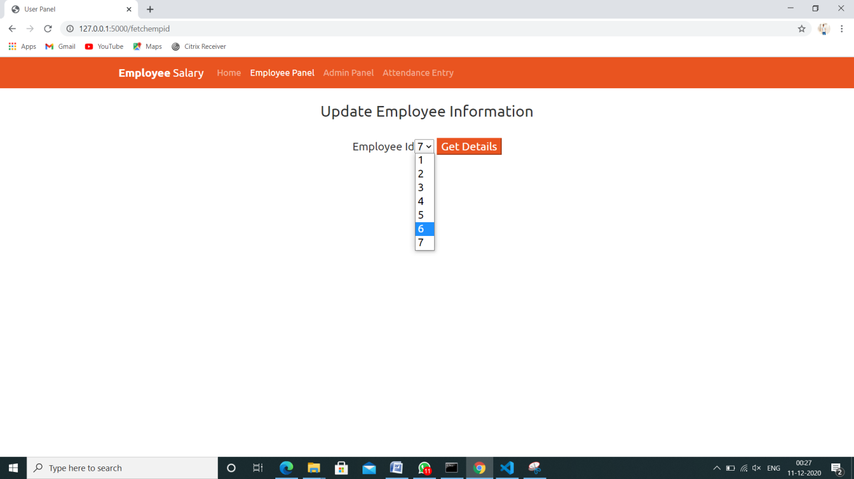

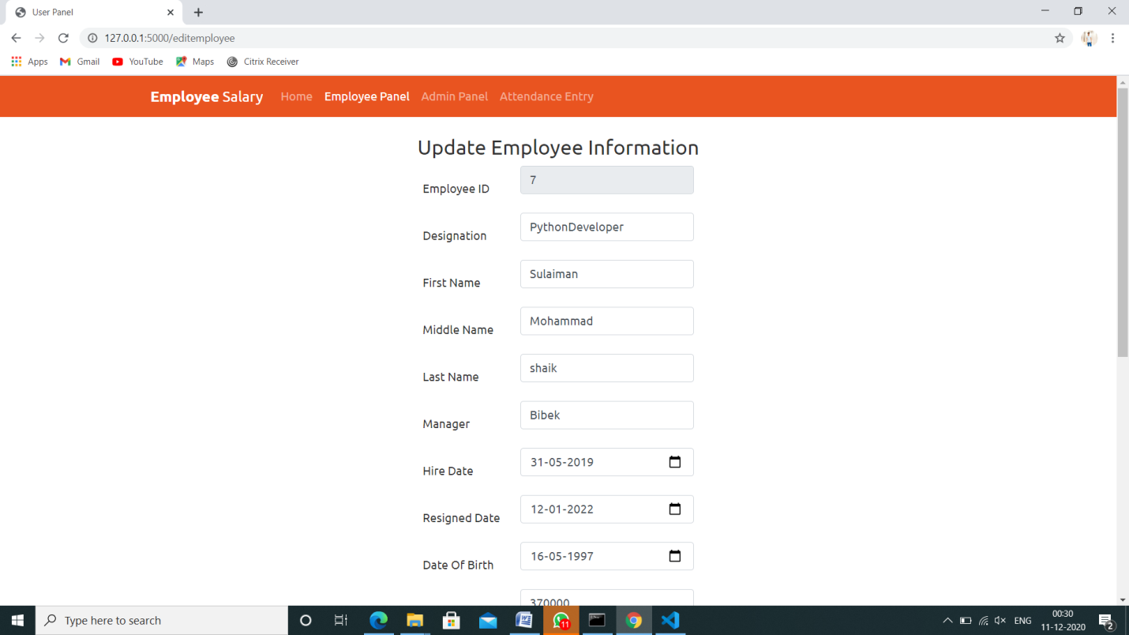

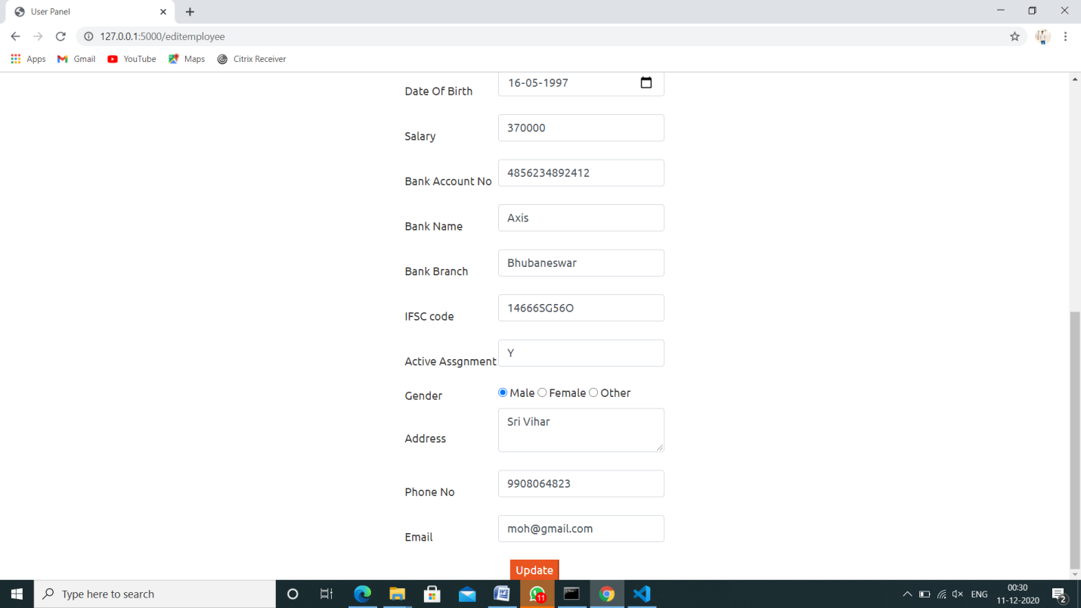

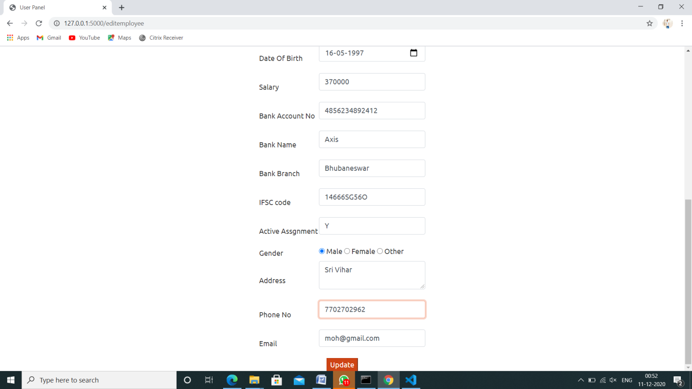

**Attendance Entry Screen:**

Here the entire records with certain fields from database will appear on the screen. Hence by selecting particular date the user can give the attendance entries for all the employees at a time instead of providing attendance for each employee.

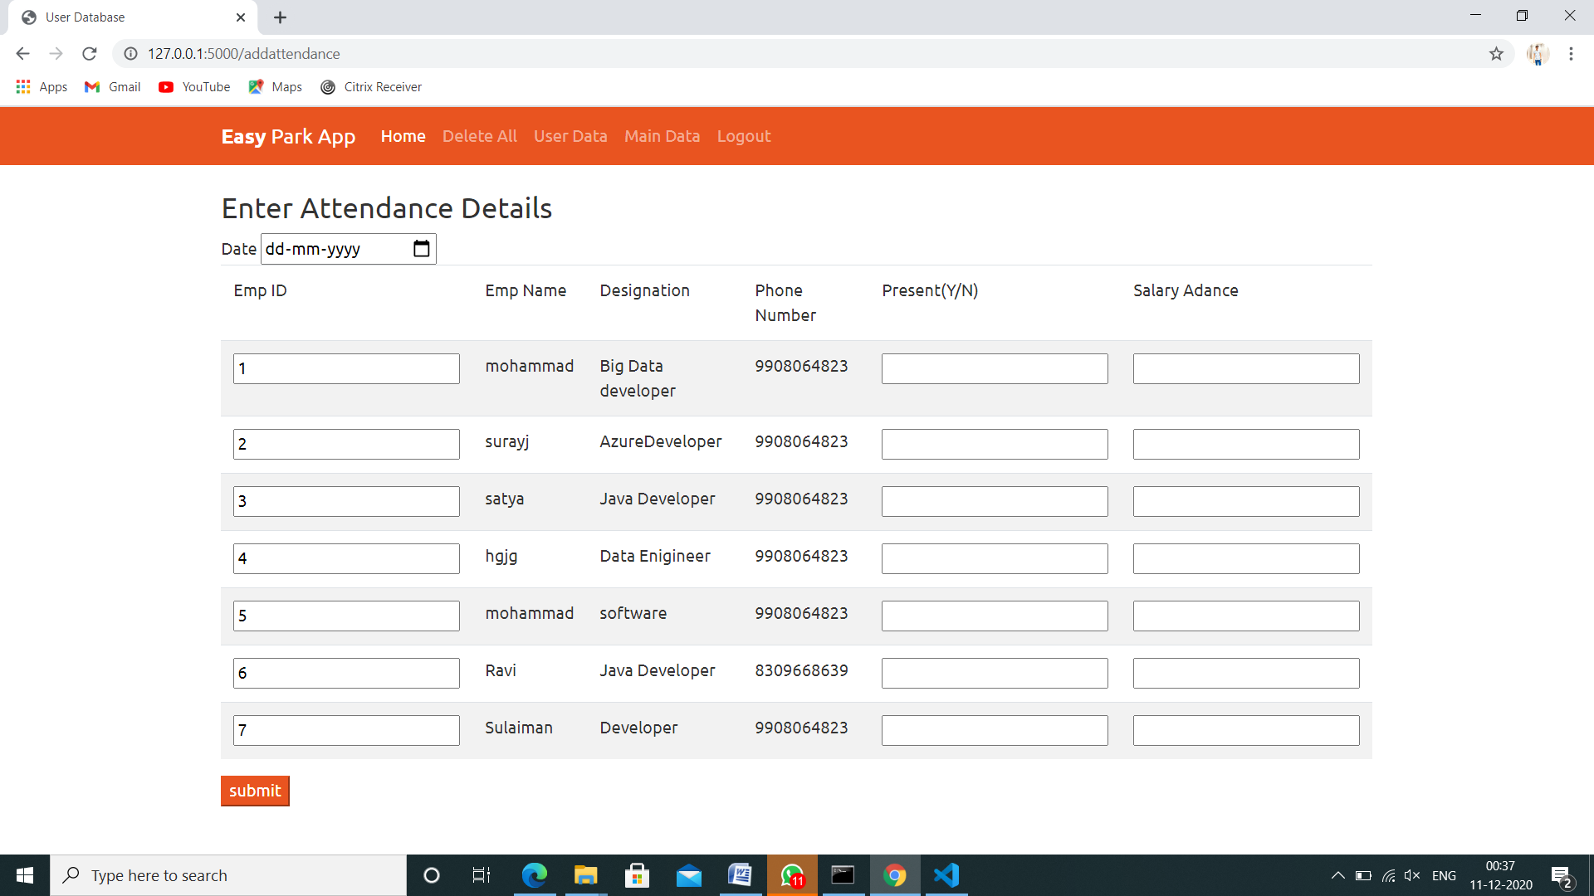

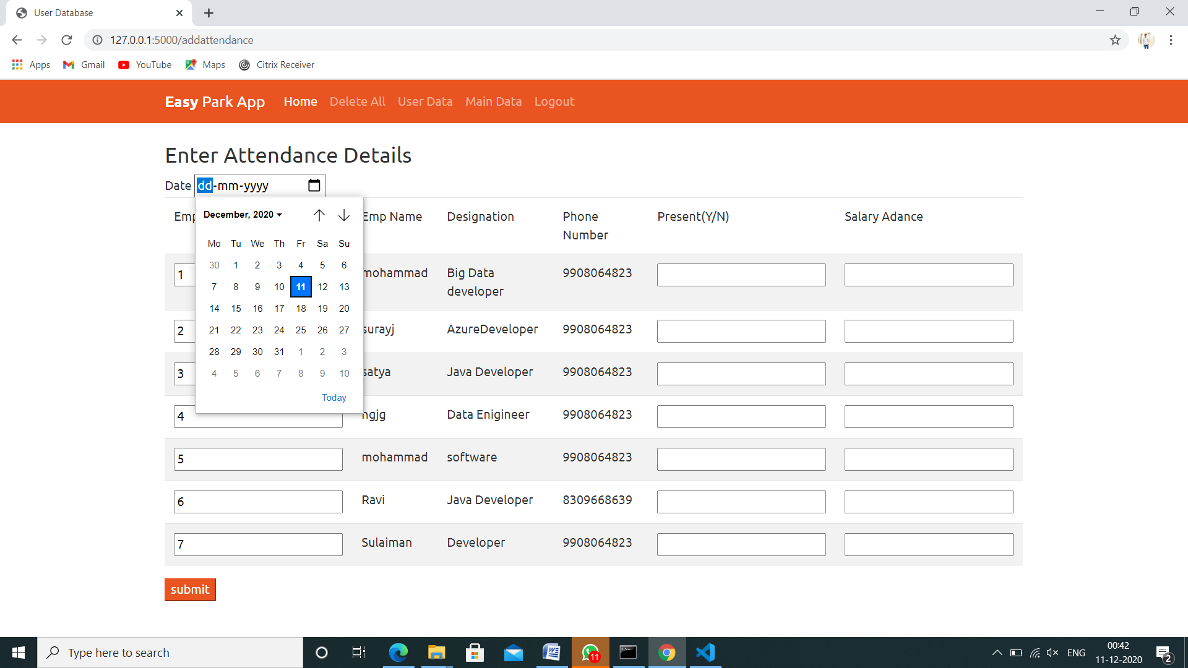

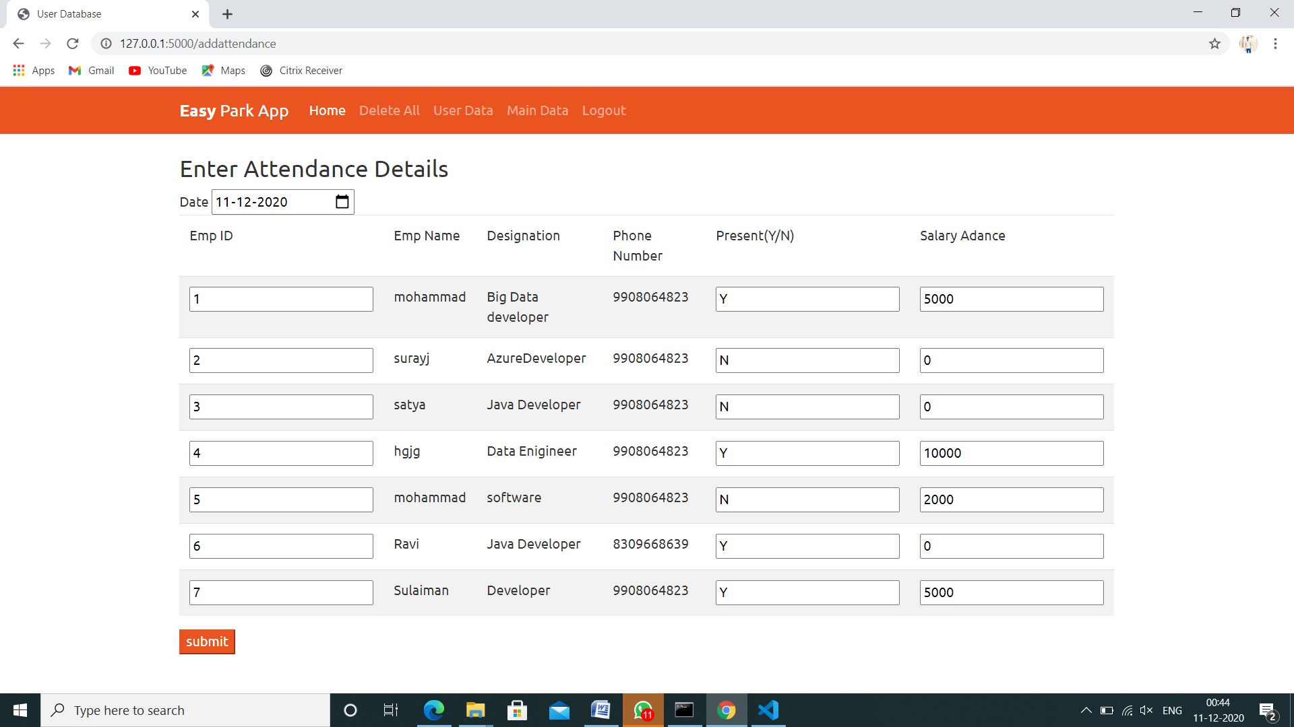

**Future Enhancements:**

* + The attendance reports will be generated as a text file and can be downloaded
  + Each employee pay slip for monthly basis can be generated.